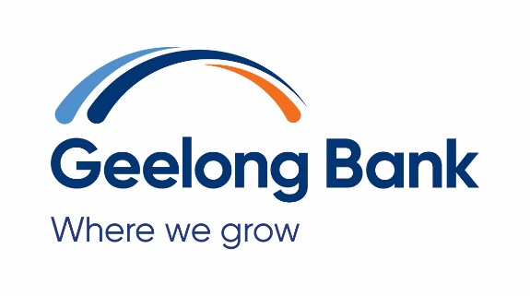

Target Market Determination – Housing Loans

|  |  |
| --- | --- |
| **Product** | Affinity Home Loan – Investment – Principal & Interest and Interest Only |
| **Issuer** | Ford Co-operative Credit Society Limited ABN 74 087 651 456 trading as Geelong Bank AFSL/Australian Credit Licence 244351 |
| **Date of TMD** | 31 January 2025 |
| **Target Market** | Retail clients who:   * are seeking a loan to purchase or renovate an investment property or refinance and investment loan * are aged 18 years or more and meet the credit assessment criteria for the product * are willing and able to offer a first registered mortgage over real property (or other acceptable security) as security for the loan   **Interest only loans**   * need an interest only period for tax planning reasons * are seeking elements of the Affinity Home Loan Package even if that means higher interest or fees   **Description of product, including key attributes**   * loan amounts from $150,000 up to 90% of value of property * loan terms of up to 30 years, with an interest only period to a maximum of 10 years * repayment frequency is monthly during the interest only period, than may be weekly, fortnightly or monthly * ability to make additional repayments * a redraw facility is available * interest rate is variable and dependent on loan to value ratio * a mortgage offset account is available * interest rate variable * must provide a registered first mortgage over real property * early repayment without penalty * package benefits include:   + up to 3 mortgage offset accounts may be opened to help you to pay off your loan sooner and minimise interest charges;   + Affinity Savings account, which pays an interest rate equivalent to the RBA cash rate;   + no obligation, free financial planning consultation with Bridges.   Refer to Interest Rates:  <https://geelongbank.com.au/about-us/disclosures-publications/>  **Fees**   * Discharge fee * Switching fee * Legal fees * Valuation fee   Refer Fees & Charges & Transaction Limits brochure:  <https://geelongbank.com.au/about-us/disclosures-publications/> |
| **Distribution Conditions** | **Distribution conditions**  This product is distributed by the issuer through the following channels:   * Head Office * mobile lenders * call centre * online   Distribution conditions for this product include:   * ensuring that clients meet the eligibility conditions for the product * ensuring that distribution through branches, mobile lenders and call centres is by appropriately authorised and trained staff * online application available   There are no other distributors for this product |
| **Review Triggers** | The review triggers that would reasonably suggest that the TMD is no longer appropriate include:   * A significant dealing of the product to consumers outside the target market occurs * A significant number of complaints is received from customers in relation to their purchase or use of the product that reasonably suggests that the TMD is no longer appropriate * A material change to the product or the terms and conditions of the product occurs which would cause the TMD to no longer be appropriate   The Product Governance Framework includes regular consideration of whether there has been a review trigger following each distribution information report. That consideration is by reference to paragraphs 154 to 156 of RG 274. |
| **Review Periods** | **First review date:** 31 January 2027  **Periodic reviews:** First review period – 12 months and every 2 years after the initial and each subsequent review |

|  |  |  |  |  |  |  |  |  |  |  |  |  |  |  |  |  |
| --- | --- | --- | --- | --- | --- | --- | --- | --- | --- | --- | --- | --- | --- | --- | --- | --- |
| **Distribution Information Reporting Requirements** | The following information must be provided to Ford Co-operative Credit Society Limited ABN 74 087 651 456 trading as Geelong Bank by distributors who engage in retail product distribution conduct in relation to this product:   |  |  |  | | --- | --- | --- | | **Type of information** | **Description** | **Reporting period** | | Significant dealing(s) | Date or date range of the significant dealing(s) and description of the significant dealing (e.g. why it is not consistent with the TMD) | As soon as practicable, and in any case within 10 business days after becoming aware | | Complaints | Number of complaints | Every [3] months | | Sales **outside** the target market | Number of sales  $ value of sales | Every [3] months | | Sales **inside** the target market | Number of sales  $ value of sales | Every [3] months | |